
Python Essentials Project Report
VITyarthi Build Your Own Project
Project Title : Student Expense Tracker
Student Name : Aniket Surwase
Registration No : 26BCE10956
GitHub Repository: https://github.com/aniketsurwase2008/student-expense-tracker.git
1. Introduction
Student Expense Tracker is a command-line Python application for recording daily expenses and generating
spending summaries. It applies Python Essentials concepts including modules, functions, classes, lists,
dictionaries, JSON, file handling, validation, exceptions, sorting, aggregation, and testing.

2. Problem Statement
Students may record small expenses in scattered notes and have difficulty calculating totals or identifying
spending categories. This project provides a local CLI workflow for adding, viewing, deleting, storing, and
analyzing expense records.

3. Objectives
• Provide a simple terminal-based expense workflow.
• Validate input before saving.
• Persist data locally in JSON.
• Provide category-wise and month-wise analytics.
• Demonstrate modular Python design and automated testing.
4. Functional Requirements
FR1 — Add expense with date, category, amount, and optional note.
FR2 — List stored expenses.
FR3 — Delete an expense by ID.
FR4 — Validate date, category, and positive amount.
FR5 — Save and load data using JSON.
FR6 — Calculate total, category-wise, monthly, and top-category summaries.
5. Non-Functional Requirements
Usability — menu-driven terminal interface with clear prompts.
Reliability — validation and exception handling.
Maintainability — separate modules for model, storage, validation, service, analytics, and CLI.
Resource efficiency — standard-library-only implementation and local storage.
Portability — designed for Python 3.9+ on common operating systems.
6. System Architecture
The CLI handles interaction; the service layer handles business operations; validators protect input quality;
the model represents an expense; analytics performs aggregation; storage manages JSON persistence. The architecture diagram is available in docs/architecture.md.
7. Design Diagrams
The repository includes architecture, workflow, use-case, class/component, sequence, and ER/storage
diagrams in the docs/ directory, matching the design-artifact requirements.
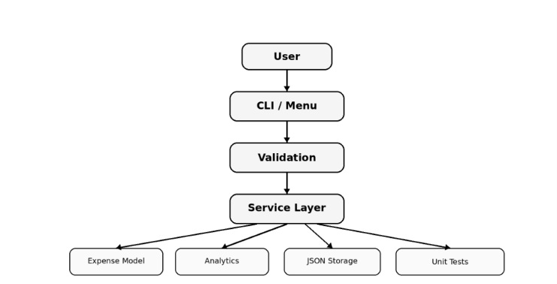

8. Design Decisions & Rationale
Dataclass provides a lightweight data model. JSON is portable and requires no external database package.
The service layer separates business logic from the CLI. Validation is centralized. Analytics is separated so
aggregation logic is reusable and testable.

9. Implementation Details
The application is split across multiple Python files. Expense objects are converted to dictionaries for JSON
serialization. IDs are generated from the current maximum ID. Analytics uses dictionary aggregation and
sorting. File writes use a temporary file before replacement.

10. Screenshots / Results
A deterministic demo with three records produced a total of n450.00, category totals of Education n250.00,
Food n120.00, and Travel n80.00, and September 2026 total of n450.00. The appendix contains the
corresponding terminal output.
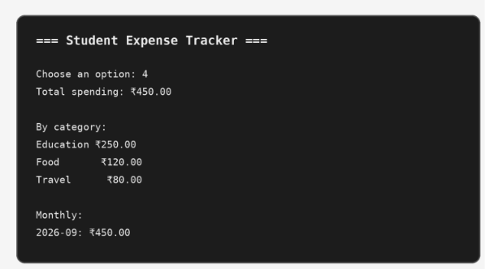
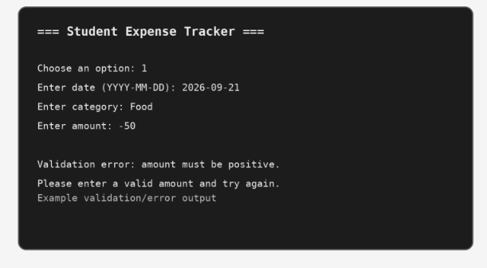
11. Testing Approach
Four unit-test scenarios are included: adding and totaling expenses, category/month aggregation, rejecting an
invalid amount, and deleting records. Run `python -m unittest discover -s tests -v`.
12. Challenges Faced
The implementation required keeping input validation separate from business logic, maintaining readable
JSON persistence, and reusing the same expense model across CRUD and analytics operations.
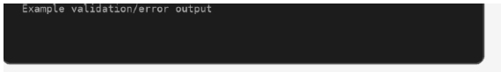
13. Learnings & Key Takeaways
The project demonstrates how a small Python program can be organized as a maintainable application. Key
takeaways include modular design, data validation, exception handling, persistence, reusable functions,
service classes, and automated tests.

14. Future Enhancements
Budget limits and alerts; CSV import/export; interactive charts; search and date-range filters; SQLite storage;
optional local profiles.
15. References
VITyarthi — Build Your Own Project: General Project Instructions & Submission Guidelines (uploaded course
document). Python Standard Library documentation for dataclasses, json, pathlib, unittest, and datetime.
Appendix A — Example CLI Result
=== Student Expense Tracker ===
Choose an option: 4
Total spending: n450.00
By category:
Education n250.00
Food n120.00
Travel n80.00
Monthly:
2026-09: n450.00
Appendix A — Example CLI Result
